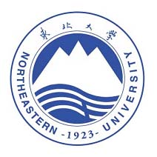
Admission Brochure for 2019 Northeastern University International Postgraduate Summer School
— Rock Mechanics for the Future
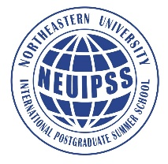
- About NEU
Northeastern University (NEU) is located in Shenyang, Liaoning Province, China. NEU is one of high-level universities designated for the state key construction of the "211 Project", "985 Project" and the “Double First Class University Plan” in China.
Founded in April 1923, NEU adheres to the research goal of serving for the national strategic and regional development. Meanwhile, it encourages free exploration and promotes collaborative innovation. The level of basic research is increasing steadily and the competitiveness of technological innovation is being enhanced. With the policy of opening up to the world, NEU has established long-term stable academic cooperation with 235 universities and institutions in 36 countries and regions.
In this summer, NEU intends to invite some renowned scholars and recruit PhD candidates from the famous universities all over the world to open an international summer school program with the theme "Rock Mechanics for the Future".
- The Program
The international summer school program is one of the graduate “Chuangke school” programs of Northeastern University. It is a high-level, innovative and open teaching program for further creating an international environment and deepening the international characteristics. It attempts to promote the construct, integration and development in relative disciplines by academic exchange and cooperation.
The summer school will invite international renowned scholars to deliver lectures and enroll PhD students all over the world. Some key elements such as courses, industrial visits, and cultural tours will be key constituent of this summer school. The courses will be provided in English in order to create an international learning atmosphere and to establish a diverse, multi-disciplinary, and multi-level classroom and campus environment.
The summer school will last 8 days. The intra- and extra curriculum activities are very intense and exciting, which designed based on the theme of rock mechanics for the future, to realize the intercultural and multidisciplinary academic communication between students and scholars. The summer school will impart knowledge entirely in English to provide a platform for international exchange, scientific research and mutual communication.
Expected effects of the activity:
(1) Members from different cultures, countries and academic learn from each other.
(2) Exchange and study with famous scholars. Participants will learn from them and inspired in other ways. Distinguished scholars will lecture and exchange ideas on a relevant topic, its research direction and latest development.
(3) Consolidate and improve students’ own research level and ability.
(4) Expand international vision and academic horizon.
Furthermore, the summer school will also arrange visits to famous enterprises and historical sites in Liaoning province.
The program is sponsored by the graduate school of NEU and undertaken by the school of Resources and Civil Engineering.
- The Date and Venue
Date: August 9 to 16, 2019.
Venue: Nanhu Campus, Northeastern University (No. 3-11, Wenhua Road, Heping District, Shenyang, P. R. China)
- Class Topics
Teaching and learning contents are mainly lecture-based, in combination with academic reports, workshops, industrial internship, and cultural experience. The scientists from different universities in Western countries will deliver lectures and communicate face-to-face with students. Specific topics will be listed in class schedule. At the end of the studies, students will receive course completion certificates.
- Professors for 2019 International Summer School at NEU
Philip Meredith

Professor of Rock and Ice Physics Laboratory, the Department of Earth Sciences, University College London, UK. Prof. Meredith has made fundamental and seminal contributions in experimental rock physics, in relation to a diversity of basic and applied problems in crustal dynamics, natural energy resources and volcanology. A major theme of Meredith’s research for over three decades has been the time-dependent behaviour of brittle rock deformation. European Geosciences Union (EGU) awarded Prof. Meredith Louis Néel medal in 2016 for his contributions in rock physics and geomechanics and for his role in stimulating international collaboration and interdisciplinary research. Professor Meredith has published over 150 papers in journals such as Nature, Science, Geology, Earth and Planetary Science Letters, Journal of Geophysical Research-Solid Earth.
Frederic L. Pellet
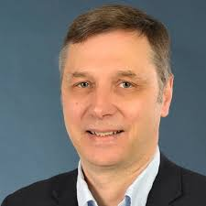
Professor Pellet is Professor of MINES Paris Tech France (2014—), Former vice President of international society of rock mechanics (2011-2015), President of the French national group of the international society of rock mechanics (2012-2016). He got the Bachelor of civil engineering in University of Applied Sciences, Switzerland (1982), Master of geotechnical engineering in University Joseph Fourier, Grenoble, France (1986), and Doctor of rock mechanics in Ecole Polytechnique Federale de Lausanne, Switzerland (1993). He was associate professor in the department of geotechnical engineering, University Joseph Fourier, Grenoble, France (1996-2009). Professor of University of Lyon, France (2009-2013). Research interests in experimental characterization of rock, rock time-dependent deformation behavior, rock damage mechanics, rock thermal-mechanical coupling process, joint behavior under dynamic and static load.
Heinz Konietzky
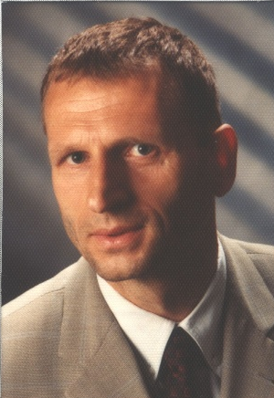
Chair Professor for Rock Mechanics and Director of the Geotechnical Institute at the TU Bergakademie Freiberg, Germany. Prof. Konietzky has longstanding experience in using continuum and discontinuum mechanical approaches to model HTM-coupled problems in geotechnics, but also to some extent in material sciences and process engineering. He is responsible for rock mechanic laboratory, where we perform static and dynamic HTM-coupled tests on rock specimen. Besides fundamental research he is also involved in dimensional and back analysis for big geotechnical projects, like radioactive waste storage facilities, tunnels, mines, foundations or deep geothermal projects (EGS). International Society for Rock Mechanics (ISRM) awarded Konietzky the "2016 ISRM Franklin Lecturer" in the 2016 European conference, was the first to receive the honorary title of German scholars.

Lanru Jing
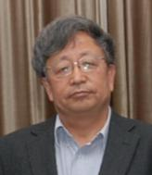
Managing editor of International Journal of Rock Mechanics and Mining Sciences, Associate Professor, Engineering Geology & Geophysics Research Group, Department of Land & Water Resources Engineering, Royal Institute of Technology (KTH). His research interests cover mathematical models and computer codes in computational geomechanics for coupled thermo-hydro-mechanical processes in fractured porous media, and contaminant transport, experimental and theoretical studies of thermo-hydro-mechanical behaviour of rock-soil/clay interfaces for geotechnical engineering problems, design, performance and safety assessments of underground nuclear waste repositories, gas/oil/hot water storage caverns and geothermal reservoir fields, and numerical modelling of granular material behaviours.
Yuzo OBARA
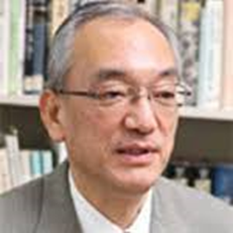
Yuzo OBARA is the professor in Faculty of Advanced Science and Technology, Kumamoto University, the head of GeoX CT center in Kumamoto University, Former President of the Japanese Society for Rock Mechanics. He was a Vice-Dean of Faculty of Engineering from 2011 to 2013 and 2016 to 2018. His interests includes mining engineering, underground space etc. Professor Yuzo obtained B. Eng. in 1978, M. Eng. in 1980 from Kumamoto University and Dr. Eng. in 1986 from Nagoya University. From 1980 to 1983, he worked as a research associate in Nagoya University. In 1983, he moved to Kumamoto University as a research associate in the Faculty of Engineering. Then he worked as a Lecture from 1988 and an Associate Professor from 1989. Since 1997, he is a Professor in the Graduate school of Science and Technology, Kumamoto University. He was also the co-chairman of 2nd and 3rd International Symposium on Rock Stress and International workshop of X-ray CT for geomaterials held at Kumamoto City, Japan. He is serving as an editorial member and reviewer of several international reputed journals. He was published many works and nearly 100 papers in international academic journals.
Tom M. Mitchell
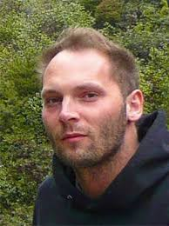
Reader/Associate Professor of Rock and Ice Physics Laboratory, the Department of Earth Sciences, University College London, UK, Deputy editor of the Journal of Geophysical Research-Solid Earth. Professor Mitchell has long been engaged in the research of rock experimental deformation mechanism, and has mastered the structure and performance of strike-slip fault zones with different scales. At the same time, he has also conducted in-depth studies on the development and evolution of fault zones and seismic properties. He has ever held a post-doctoral research assistant position at Hiroshima University and Ruhr-University Bochum. He also conducted his visiting research at Brown University, University of Otago, and Pontifical Catholic University of Chile.
Hanbing Bian
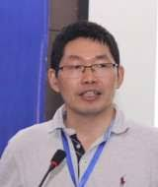
Associate professor in the laboratory of microstructure and material mechanics, Lille University, France. His research focuses on the mechanical behavior characterization of geo-materials, especially for their multi-physically coupling effects and the numerical simulations, as the member of AFM and AUGC, he is also the review of more than 10 international journals, participated in more than 10 scientific research projects, including the cooperation with CEA, TOTAL and ANDRA, published more than 20 scientific reports and more than 70 journal papers.
Yoshitaka NARA
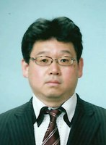
Dr. Yoshitaka Nara is Associate Professor of Earth Crust Engineering Laboratory, Graduate School of Engineering, Kyoto University, Japan. He is also a member of American Geophysical Union (AGU), European Association of Geoscientists and Engineers (EAGE) and International Society for Rock Mechanics (ISRM). He graduated from Hokkaido University in Japan in 1999, 2001 and 2004 with a bachelor’s, a master’s and a doctor’s degree, respectively. Dr. Nara served as a post-doctor fellow at the Center of Excellence (COE) (2005.09~2008.03) and the fellow of the Japan association for the advancement of science at the graduate school of engineering, University of Hokkaido, Sapporo, Japan (2008~2011). He was invited as an honorary fellow in the department of earth sciences at University College London (2008~2009 and 2010.03~08). His research interests focuses on subcritical crack propagation and time-dependent deformation of rocks. He has published over 30 international journal papers in Journal of Geophysical Research-Solid Earth, Int J Fracture, Int J Rock Mech & Min Sci, etc.
Piyal Wasantha
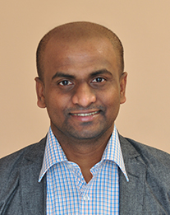
Senior Lecturer of Victoria University, Australia. Dr. Wasantha was an Alexander von Humboldt Award Holder in Germany and a visiting scholar at Oxford University. His research interests include rock mechanics and hydraulic fracturing. He has published more than 40 papers in Journal of Geophysical Research-Solid Earth, Journal of Prtroleum Science and Technology, Engineering Fracture Mechanics, Rock Mechanics and Rock Engineering etc.
Yilin Gui
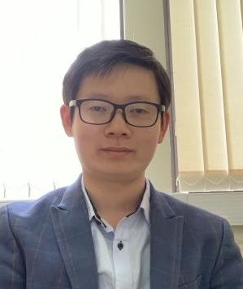
Dr. Gui is Lecturer in Geotechnical Engineering in Newcastle University, UK. Dr Gui is also the Peer Mentor Coordinator of the Civil Engineering program and the Deputy Degree Program Director for Master of Science in Geotechnical Engineering and Engineering Geology. is research interests are focused on rock and soil mechanics, computational and constitutive modelling of geomaterials and Geoenvironmental Engineering and other related areas. His current research projects include THM in rock mechanics, environmental impact on soil structures and application of computation methods in Geotechnics.
- Enrollment Information
(1) Number of participants
The summer school plans to enroll 30~40 students at the level of graduate (PhD) education from different academic and research institutes, in which no more than 25 students from mainland China.
(2) Applicants Eligibility
1) Applicants with good physical health and under 35 years old.
2) Applicants should be the fulltime PhD candidates.
3) Research fields: Rock mechanics, mining engineering, engineering mechanics, geological engineering, civil engineering, etc.
4) Research should be related and have been achieved important results.
5) Have good communication skills in English.
(3) Registration and admission
1) Registration time: Now until June 30th, 2019
2) Application materials, the host unit examines and approves the admission.
Please submit the electronic copies of the following application materials to the email address of the summer school staff.
a. Application form (See the attachment);
b. A letter of recommendation signed by professor;
c. Student card (Domestic students only).
3) Admission.
We will invite experts in relevant fields to make a comprehensive evaluation of the applicant based on the materials provided by the applicant, and will take this as the basis for admission. The admission results will publish in the website of Northeastern University (http://www.graduate.neu.edu.cn/) before July 8th, 2019. At the same time, we will send the admission notice to the successful applicants by email.
- Travel and Accommodations
There are no tuition fees and registration fees. NEU will cover round-trip economy air tickets or train tickets, accommodations, meals for all the successful applicants during the period of the summer school in Shenyang.
- Contact
Prof. Tao Xu
Tel: 0086 24 83689232. Email: xutao@mail.neu.edu.cn
Prof. Wan-Cheng Zhu
Tel: 0086 24 83687705. Email: zhuwancheng@mail.neu.edu.cn
Prof. Qing-Lei Yu
Tel: 0086 24-83691022. Email: yuqinglei@mail.neu.edu.cn

